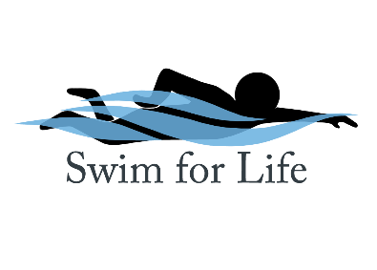

Swim Lesson Scholarship Application
Applications for financial assistance for swimming lessons will be reviewed as they are received. The SFL board will make determinations and notification as applications are received. Please include last year's federal income tax return (1040) and, if applicable, all current month's pay stubs for all household members. If you did not file a 1040 in the last year, please provide us with form 4506 to verify that you were not required to file taxes. Please see the list of additional documents that you may submit; these are not required but may aid in the Swim for Life Board of Directors' decision making process. Incomplete applications will not be considered. Scholarships will be applied to the learn-to-swim program at Snohomish Aquatic Center for group lessons meant for children of K-12 age up to level 4. Awards will amount to 25% to 50% off the cost of a session of lessons.
Documentation | Source | Monthly Income |  | Documentation | Source | Monthly Income
□ | Last year's federal income tax return |  |  | □ | Temporary Assistance for Needy Families (TANF)
□ | Last month's pay stubs (for all household members) |  |  | □ | Unemployment
□ | Social Security |  |  | □ | Foster Care Stipend
□ | Disability |  |  | □ | Housing Assistance
□ | Child Support |  |  | □ | Other (list)
□ | DSHS Denial Letter |  |  | □ | Total Monthly Income:

Name
Mailing Address
Phone Number
Email
Ethnic Origin (optional) | □ Am. Indian/Alaska Native □ Asian □ Hispanic/Latino □ White □ African American or Black □ Native Hawaiian or Pacific Islander
Employer or School Name
Household Size |  | Adults: Children (under age 18):
Household Member Names: |  |  |  |  |  |  |  | DOB: |  |  | Employer/School:
Do school-age children qualify for free or reduced lunch? |  |  | □ Yes | □ No |  | Would you be willing to give a testimonial about the benefit of a Swim for Life scholarship? |  |  |  |  |  |  |  |  | □ Yes |  | □ No
Please explain why you would like to be considered for a Swim for Life scholarship. Include any special circumstances (i.e. medical bills, student loan debt, unemployment, disability, etc.):
Indicate which day(s) of the week you would like to take lessons: □ M □ T □ W □ Th □ Fri □ Sat
Have you ever received a scholarship from Swim for Life before? □ Yes □ No
I certify that the above information is true and complete to the best of my knowledge.
Applicant Signature |  |  |  |  |  |  |  |  |  |  |  |  |  | Date

Turn in or mail this completed form and documentation into the Snohomish Aquatic Center at 516 Maple Ave., Snohomish, WA 98290. (Attn. Swim for Life)

